Principles of General Imaging in Pediatric Patients
Author: Kelli Welch Haynes, Ed.D, RT (R), FASRT, FAEIRS

Outline
- Introduction to Pediatric Imaging
  - Principles of pediatric imaging
  - The Environment
- Specific Pediatric Considerations and Concerns
  - Safety
  - Communication
  - Respect for Patient/Parent/Caregiver/Guardian Rights and Dignity
  - Adequate Care and Service to the Patient/Parent/Caregiver/Guardian
  - The Approach
  - Patients with special needs
  - Physical considerations
  - Psychological considerations
- Age-Based Development
3.1 Premature infants
3.2 Neonate
3.3 Infant
3.4 Toddler
3.5 Preschooler
3.6 School-Age
3.7 Adolescent
- Reducing radiation exposure
  - Proper centering and exposure factors
  - PA projections
  - Effective immobilization
- Common imaging examinations
  - Chest
  - Hip
  - Abdomen
  - GI and GU examinations
  - Skull
  - Extremities
- Examinations Unique to the Pediatric Patient
  - Bone Age
  - Aspirated and Ingested Foreign bodies
  - Scoliosis
  - Suspected child abuse
- Conclusion

Learning Objectives
- Explain various ways to approach pediatric patients and their parent/caregiver/guardians.
- Describe the unique considerations and concerns associated with pediatric care.
- List methods to protect pediatric patients from injury and unnecessary radiation exposure.
- Discuss standard pediatric medical imaging examinations.
- Identify classic radiographic indicators of child abuse.
Highlights
- Children are not just small adults; imaging pediatric patients requires special techniques.
- Radiologic technologists must build confidence in pediatric communication and immobilization techniques to be successful when imaging pediatric patients.
- Radiologic technologists should be familiar with the approaches for each age group to ensure a positive experience and examination for the patient.

Introduction
Imaging pediatric patients is extremely valuable as a diagnostic tool in the pediatric population, but it comes with several distinct challenges compared to imaging adults. Some challenges include dedicated imaging protocols to acquire the images, a possible need for sedation or general anesthesia for more lengthy procedures such as MRI, specific training for the radiologic technologists involved, and, most importantly, it requires consideration for radiation exposure if ionizing radiation is being used. One of the challenges for radiologic technologists is to gain the child's trust and cooperation before and throughout an exam, which can be difficult in children who may be ill and have pain.1 The increased radiation sensitivity of growing organs and children's longer expected life spans make them more susceptible to the harmful effects of radiation. The ALARA principle (As Low As Reasonably Achievable) should be strictly followed to prevent the detrimental effects of ionizing radiation.

Principles of Pediatric Imaging
Children are not just small adults; imaging pediatric patients requires special techniques. Pediatric imaging can be one of the most confounding experiences. Radiologic technologists must gain skills in multitasking, such as quickly engaging and reassuring the child using an age-appropriate approach, then switching gears to gain the confidence of the parent/caregiver/guardians, explaining and instructing them on immobilization techniques for the examination, all the while keeping in mind that other patients may be waiting.

Dedicated pediatric imaging departments with dedicated radiologic technologists may result in greater compliance with pediatric protocols and significantly reduced patient dose.1 Children must be approached on their level. Radiologic technologists must build confidence in pediatric communication and immobilization techniques to be successful when imaging pediatric patients.1 There are many similarities to adult radiography, including basic positioning and image quality assessment. The approach to the child is the most significant difference. Try to look at the world through the eyes of the child.3

The Environment
Research has shown that the atmosphere of patient care affects the recovery rate. Pediatric centers should provide an appealing and pleasing atmosphere to children of all ages. Waiting and imaging rooms that are well equipped can reduce anxiety and act as a diversion for both the parent/caregiver/guardians and the children. There are two areas to consider; the waiting room and the imaging room.2,3

Waiting Room
The environment in which patients are treated and recover plays a significant role in the recovery process.2 A comfortable space with kid-friendly decor makes waiting a lot easier. Children are attracted to and amused by toys, thus leaving the parent/caregiver/guardians free to check in, register, and ask pertinent questions. Gender-neutral toys or activities, such as coloring with crayons at a small age-appropriate table, are most appropriate. Books or magazines for older children are helpful. A friendly waiting room is essential to decrease a child's anxiety and to help parent/caregiver/guardians stay calm while waiting for the imaging procedure to begin.1

Imaging Room
Pediatric imaging centers are becoming more kid-friendly with elaborately decorated rooms and scanners. The result? Happy patients and potentially no sedation. Imaging rooms may contain movie goggles, basketball stars, images of fish swimming through the room, or monkeys on the equipment. These distraction techniques in children's radiology units make kids and parent/caregiver/guardians happier and often decrease the need for sedation during the studies.
Support from parent/caregiver/guardians is usually helpful.3 It is best practice to prepare the imaging room before the patient enters, gather image receptor(s), and approximate centering of the tube to the image receptor. It is also best to dim the lights and gather immobilization devices. When the patient enters the room, explain the procedure to the parent/caregiver/guardian and the child. Lengthy examinations pass quickly with age-appropriate music or videos playing. After the procedure is over, emphasize how cooperative the child was, even if they were kicking or screaming. Then, explain to the parent/caregiver/guardian where to wait or what to do next.

Specific Pediatric Considerations and Concerns
Diagnostic imaging has become an integral part of the healthcare system.3 This includes using various modalities, some of which may involve exposure to harmful ionizing radiations. Due to the rapid advances in imaging technology, such as the introduction of multi-detector arrays and fast magnetic resonance imagining (MRI) protocols, the number, and variety of imaging procedures are dramatically increasing.4 Using these imaging modalities is extremely helpful in supporting routine pediatric care pathways and helps in initiating appropriate and timely treatment. However, imaging children poses distinct challenges to radiology departments. Various efforts must be made to provide effective and quality pediatric imaging services. Specific pediatric considerations include safety, communication, respect for patient/parent/caregiver/guardian rights and dignity, and provision of adequate care and service to the patient and family.2

Safety
Modern approaches to patient safety have shifted from eliminating human error to developing robust systems and processes that create safe outcomes, despite the inherently dangerous environment in which healthcare providers treat patients.3 Harm from medical error is a difficult challenge in healthcare, including radiology. Modern approaches to patient safety have shifted from focusing on individual performance and reaction to errors to developing robust systems and processes that create safety in organizations.

Childproofing the imaging department is similar to childproofing your home. It is best practice never to leave your patient unattended. Also, small items that could be swallowed should be kept out of reach.2

Communication
Communication is an essential component of every imaging examination.1 Reassurance, praise, and conversational distraction are three ingredients of successful communication for pediatric patients.2 Introduce yourself while making eye contact with patients and parent/caregiver/guardians. Explain the radiography team's role. Always speak to a child using age-appropriate language. Explain the examination, take a patient history, and explain pertinent medical information on a level the family can understand. It is best to avoid medical jargon and unfamiliar terms. Before beginning the exam, ask if there are any questions or concerns.

Respect patient/parent/caregiver/guardian rights and Dignity
Listen to patients' and/or parent/caregiver/guardians questions.2 Keep in mind that some speak English as a second language, which may impede their understanding of the exam. Be mindful of cultural preferences and taboos. If possible, seek assistance within your institution.

Adequate care and service to the patient and parent/caregiver/guardian
We have discussed the importance of a child-friendly environment. If possible, use appropriately sized equipment.3 Seek assistance from parent/caregiver/guardians as needed, depending on the child's age. Also, use a soft pad with a sheet on the exam table if possible.

The Approach

Approaching the Parent/caregiver/guardian
The radiologic technologist may wonder whom to speak to, the parent/caregiver/guardian/caregiver/guardian or the child.1 The answer is easy; if the child is old enough to comprehend, speak directly to the child. Use age-appropriate language at their eye level. The parent/caregiver/guardian will listen and appreciate the special attention given to the child. If the child is too young to understand, explain the examination to the parent/caregiver/guardian. It is best to use lay terms and simple sentences. Keep in mind; parent/caregiver/guardians are often stressed and distracted. Simple instructions will aid in understanding. Ultimately, successful communication is the key to a successful examination.

Parent/caregiver/guardian participation depends on the department's philosophy or protocols and the parent/caregiver/guardian and patient's wishes.4 Parent/caregiver/guardians participating in the procedure are encouraged for several reasons. The parent/caregiver/guardian can watch the child if the RT and/or radiologists need to attend to equipment, contrast media, the imaging receptor, or other issues.4 The RT may need to leave the room. The parent/caregiver/guardian can assist with immobilization. A parent/caregiver/guardian who witnesses the procedure cannot doubt professional conduct. Parent/caregiver/guardian participation benefits parent/caregiver/guardians and the RT.1 Informed parent/caregiver/guardians can help explain the procedure to the child. Patient education pamphlets can also help. However, in some instances, parent/caregiver/guardian presence is not advised because their presence may agitate the child even more.

Approaching the Child
Good communication is essential.3 Greet the parent/caregiver/guardian(s) and the patient with a warm smile. Bend down and talk to the child at eye level. Introduce yourself and confirm that you have the correct patient. Prepare the exam room beforehand.3 Use the child's age to determine the approach. Briefly explain the procedure. Use sincere praise. Immediate praise is needed for young children (ages 3-7). For example: "You were very still. Thank you!" Employ distraction techniques; Ask about school, sports, siblings, pets, etc. Become familiar with popular cartoons, TV shows, music, sports figures, etc. Knowledge of their world builds rapport. Answer questions with complete honesty; this builds confidence and establishes your credibility. Do not dwell on unpleasantness. Give children an option when the outcome is the same.

Patients with Special Needs
The RT should consider age when approaching patients with physical and mental disabilities.2 Begin communication with the child. If unsuccessful, talk to the parent/caregiver/guardians, but continue to make eye contact with the child. Children appreciate being talked to rather than being talked about. Caregivers are most knowledgeable about the patient’s needs. Consultation and preparation before the exam are helpful. After introducing yourself, briefly explain the procedure to the child. Place the wheelchair or stretcher parallel to the imaging table and ask the child if help is needed for the transfer. Communicating with a child who has a mental disability can be difficult, depending on the severity of the disability. Some patients react to verbal stimuli. Loud or abrupt phrases can startle and consequently agitate them.

Patient Care: Physical considerations
Depending on the level of care being provided, children may arrive in the department with intravenous (IV) tubes, chest tubes, colostomies, etc.2 The RT needs to be aware of the purpose and significance of these and the following; What are the specific instructions regarding the care and management of children while in the department? Will a nurse or another health care professional accompany the child? Will physical limitations influence the way the examination is performed? Many inpatients are on a 24-hour urine and stool collection. If the diaper is changed in the department, save it so floor personnel can weigh and assess it. Be sure to know the policy on intravenous (IV) line management; it is often required to call a nurse or for a nurse to accompany a pediatric patient with an IV.

Infection Control and Standard Precautions
Prevention of the spread of contagious diseases is of primary importance; handwashing is the most important means of stopping the spread of infection.1 Clean all equipment that comes in contact with a patient and always follow standard precautions-all blood and body fluids are to be considered infected; this protects the patient and the RT.

Protection from injury
To avoid the possibility of injury, supervise children during transport and while they are in the department.2 Regularly inspect immobilization tools to ensure they are maintained and in working order. In the event of an injury, however minor, file a report documenting the specifics of the incident.

Patient Care: Psychological considerations
The RT will encounter the pediatric patient in a variety of settings, including the emergency department, the outpatient setting and the inpatient setting.²

Emergency setting
When an accident happens, emotions run high, thought processes are clouded and the ability to rationalize is often lost. For the parents of the child who had been injured, another power factor that is often involved is guilt. The RT should greet the patient/parent/caregiver/guardian and then describe the procedure. Maintain a calm perspective and provide reassurance with a calming tone. Only one individual should provide instructions to the child. Once the procedure is completed, explain to the parent/caregiver/guardian where to wait and what to expect.

Inpatient setting
The inpatient setting is often stressful due to the degree of illness of the child. The child is usually fearful due to separation from parents, the strange environment, and other extenuating circumstances. The parent/caregiver/guardian is also stressed because they may be struggling with being off work, siblings at home, and/or the health of their child.

Outpatient setting
The outpatient setting is typically the least stressful environment. However, lengthy waiting times can cause frustration for the patient/parent/caregiver/guardian. The RT should communicate the cause for the delay and listen calmly and sincerely.

Age-Based Development
The pediatric patient may not always fit neatly into the following developmental stages for various reasons, such as pathology, developmental delays, parenting, chronic illness, mood during the exam, etcetera.² Some universal approaches to interacting with children will always apply, such as making eye contact, addressing their fears, making them comfortable, etcetera. Radiologic technologists should be familiar with the approaches for each age group to ensure a positive experience and examination for the patient.

Premature Infants
Typically, mobile radiography and procedures in gastrointestinal (GI) and genitourinary (GU) using fluoroscopy encompass most of the contact RTs will have with premature infants.3 If possible, elevate the room temperature by 10-15 degrees before the patient arrives. Generally, an intensive care unit (ICU) nurse will accompany and care for the patient. However, the RT will need to explain the procedure to the nurse. It is best practice to allow the patient to remain in the incubator/warmer until just before the procedure. Discuss the patient's immobilization plan with the nurse to accommodate the patient’s medical needs.

Neonate (0-28 days)
To increase security and comfort: maintain swaddling until you are ready to perform the examination.3 Decrease noise levels and dim bright lights. Maintain and warm room. Speak soothingly and avoid sudden and quick movements. Have warming lights available. Communicate procedures to caregivers and involve caregivers in soothing and calming the infant. Pacifiers, a personal blanket, and soft singing can all be helpful in soothing the newborn.

Infant (28 days to 18 months)
The first rule of imaging infants is never to leave the infant unattended; the RT or parent/caregiver/guardian/caregiver/guardian should always have a hand on the infant.3 The second rule is always to cushion the exam table under the infant's skull. During different periods of infancy, babies experience separation and stranger anxiety. Infants require warmth, security, and nourishment. Do not distinguish among caregivers. They are startled by loud stimuli (minimize loud noises). Infants can be comforted by pacifiers and familiar objects. Consult with caregivers to understand what soothing techniques work with their infant and what distresses their infant. Avoid flexing the baby’s head forward, which may cause respiratory distress.

Toddler (18 months – 3 years)
Toddlers can be a challenge.3 Toddlers can seldom keep their bodies still, which can be problematic. They also have a short attention span and become overwhelmed quickly. Toddlers fear medical experiences and often become unruly while being positioned for an exam. Allow the child to keep a toy or other soothing object during the examination. Use distraction techniques, sincere praise, and positive statements. ​

Preschooler (3-5 years)
Potential obstacles include fear of the unknown and unfamiliar people.3 It is best practice to establish rapport and to provide time to familiarize the child with the environment and equipment. Communicate using directive statements. Use positive affirmation for cooperation. Very curious and enjoy fantasy and games. Give explanations at the child's eye level. Cooperate readily if treated like a game. Preschoolers respond to praise. Show the child how the collimator light works and let them turn it on. Use a camera analogy to explain the x-ray tube. Avoid unnecessary equipment manipulation. Encourage the child to cooperate. An agitated or aggressive child will not cooperate and respond to games or distraction techniques. Parent/caregiver/guardian/caregiver/guardian involvement can be instrumental to the success of the exam.

School-Age (6-12 years)
Positive affirmations and reassurances are incredibly beneficial for this age group.3 Satisfy natural curiosity by using age-appropriate explanations. Break down the exam into steps, letting the child know exactly what you expect and, most importantly, letting the child know before you do anything. School-age children are the ideal age for inexperienced RTs. This age group is eager to please, easy to communicate with, and easy to palpate. This group is also very modest, so protect their privacy. Avoid unfamiliar medical jargon, as this will only confuse school-aged children and can decrease their ability to cope. Be very literal—avoid words that can be misconstrued, like "shoot," "shot," or "dye." School-age children benefit from being given realistic choices. It provides a sense of control and entitlement, which enhances coping. Coping and distraction techniques, such as taking deep breaths, blowing bubbles, listening to music, watching a movie, or playing on a tablet, can be instrumental in helping children cope during exams.

Adolescent (12-18 years)
When imaging adolescents, respect their need for privacy; providing a private changing room, knocking before entering their exam room, and limiting the number of RTs will help alleviate stress.3 If male and female RTs are available, ask the patient if they have a preference. Communicate directly with the patient. Since menstruation onset varies, sensitive issues arise due to the possibility of pregnancy. Ask female patients questions alone, not in front of the parent/caregiver/guardian. Preface question- let them know you need to ask a sensitive question. A female radiologic technologist should inquire about menstruation in this age group. If the patient has begun menstruation, ask about the possibility of pregnancy. Follow the questioning with an explanation that it is unsafe for the baby to receive radiation. Validate and reassure their emotional response to the exam. Preteens and adolescents can understand instructions. They are often worried about recovery. They need clear explanations and questions answered. They want to be treated as adults. Deep breathing, listening to music, or conversing with the RT can help put the patient at ease.

Reducing radiation exposure

Proper centering and exposure factors
A conscientious RT can do much to protect children from exposure to unnecessary radiation.2 To contribute to safe practice, the RT should direct efforts toward properly centering and selecting technical exposure factors and precise collimation.

PA projections
Instead of the anteroposterior (AP) projection, use the posteroanterior (PA) projection of the thorax and skull to reduce the amount of radiation reaching the breast tissue and the lens of the eye.

Effective Immobilization
The two most successful tools for pediatric radiography are effective immobilization and good communication skills.3 Respected pediatric RTs approach patients and parent/caregiver/guardians with kindness and take care to maintain patient comfort throughout the procedure. Despite effective communication, restraining children during imaging examinations is often necessary. Effective immobilization will reduce repeats and follow the ALARA (as low as reasonably achievable) principle.

Immobilization should never be a traumatic, torturous event for a child. It should never cause harm.3 Aside from regular sponges and sandbags, three tools are frequently used in pediatrics; Velcro compression band (also called Bucky or body band), strips of reusable Velcro, and the Pigg-O-Stat. The Bunny Method is also an effective immobilization technique used for infants.

Pigg-O-Stat
The Pigg-O-Stat is typically used for the ages of newborn to 3 years.2 The parent/caregiver/guardian should stand to the side and hold the child’s arms above their head. The device can be used for upright chest, abdomen, thoracic, and lumbar spine examinations. The device has a large support base on wheels, an adjustable seat, and Plexiglas support or sleeves. The device is mounted on a turntable, enabling quick rotation from PA/AP to lateral projections. It typically requires two persons to use it.

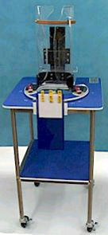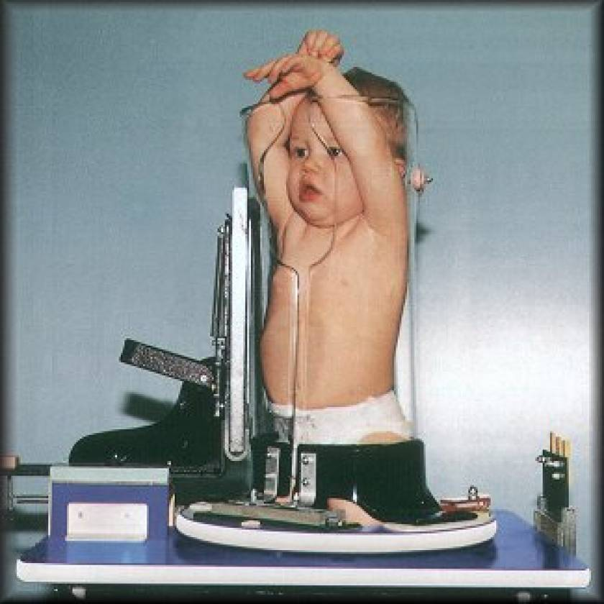
Figure 1. a) A Pigg-O-Stat device. b) A child positioned in a Pigg-O-Stat for a chest x-ray.
Images courtesy of Modern Way Immobilizers, Inc.

Bunny Method
Unless the child is asleep, all patients 3 years and younger should be immobilized using the bunny method, illustrated in Figure 2.2 There are many ways to wrap a baby; however, a well-wrapped baby remains that way through 5-7 images. The Bunny method is common for cranial radiography. Here are the steps for successful utilizing the bunny method.
- Using a cotton wrap, fold the top edge of the wrap down by about 20 cm; lay baby on the wrap with her shoulders in line with the fold of the blanket.
- Place one of the baby's hands under the fold of the blanket;
- Bring the edge of the wrap across the baby’s body and tuck it under the baby's legs.
- Place the other hand under the fold of the blanket;
- Tuck the other edge of the wrap across the baby's body under her back.
- Fold any extra length up and under the baby's legs. While babies like to be wrapped firmly, ensure the wrap is not too tight.

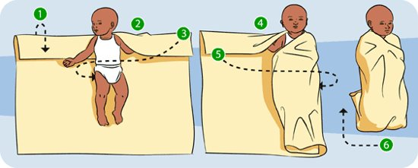

Figure 2: The Bunny Method
Image provided by: 

Common Imaging Examinations

Chest
The most common exam performed is the chest x-ray.3,2 This examination should be performed when the child is awake. Challenges include preventing motion and rotation, freeing lung fields of superimposition, and obtaining a good inspiratory effort. Images acquired on inspiration are essential for accurate diagnosis. Expiratory images can lead to erroneous interpretations. If needed, place the child in the Pigg-O-Stat. Explain to parent/caregiver/guardian what it is and why it is needed. Explain to the parent/caregiver/guardian assisting that the child will probably cry, but that helps to obtain the exposure on inspiration.

Evaluating Chest images
PA-kVp range 80-90.2 Visualize peripheral lung markings. Visualize intervertebral disk spaces through the heart. Sternum, airway, and vertebral structures should be superimposed. Visualize the trachea, costophrenic angles, and 9-10 ribs. Figure 3 demonstrates PA and lateral chest images with adequate recorded detail, including visualization of intervertebral disk spaces, and the entire lungs including the costophrenic angles. Due to proper technical factors, the images demonstrate complete opacification of the left hemithorax with tracheal and mediastinal shift to the right.

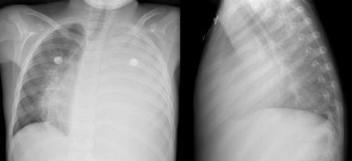
Figure 3: PA and lateral chest images. Image courtesy of PediatricEducation.org

Hip radiography
Most often ordered to assess Legg-Calve-Perthes Disease, which results from an interruption to the blood flow to the head of the femur in a young patient.2 New bone formation at the growth plate can be abnormal when this occurs. Lack of blood supply causes osteonecrosis. Legg-Calve-Perthes Disease is most common in boys between the ages of 4 and 8. It is usually diagnosed when the child is found to have a limp and/or complains of pain. Both sides are imaged for comparison. Symmetric positioning is critical. Never touch the symphysis pubis of the child. Use the trochanters as a guide for positioning. Remove diaper. Check for rotation of the pelvis. Use Velcro bands and strips to immobilize lower limbs into position.

Evaluating Hip Images
Evaluate for rotation and symmetry by the midline structures.2 Anatomy should include crests of the ilia to the upper femora. The bony trabecular pattern should be visible as an indicator of sufficient detail. Figure 4 demonstrates a typical series for hip examinations, which includes the pelvis and both hips. The pelvis shows no evidence of fracture, avascular necrosis, or slipped capital femoral epiphysis. The only remarkable finding is a subtle one - the left femoral head on both views is slightly more displaced laterally than the right femoral head, suggesting the presence of a left hip effusion.

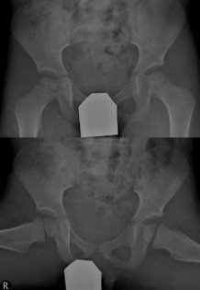
Figure 4: AP (top) and frog-leg (bottom) images of the hips, including the pelvis.
Images courtesy of Pediatriceducation.org

Abdomen
Abdominal radiography in children is requested for many reasons.2 Even though an abdominal series for adults includes a PA projection of the chest, it is not included in the series for children. To keep radiation exposure to a minimum, the pediatric abdominal series need only include the supine abdomen and an image to demonstrate air-fluid levels. For the supine projection, immobilize as described for the hip and pelvis. The Pigg-O-Stat can be used for the upright projection. Figure 5 demonstrates multiple dilated small bowel loops with air-fluid levels. There is also a suggestion of a soft tissue fullness in the right lower quadrant displacing the bowel loops centrally.
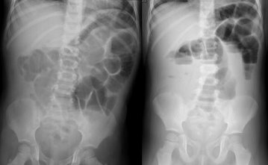
Figure 5: Supine (left) and upright (right) images of the abdomen.
Images courtesy of PediatricEducation.org

GI and GU Procedures
Gastrointestinal (GI) and genitourinary (GU) exams are tailored to individual patients to reduce radiation exposure.6 Explain the procedure to the patient and parent/caregiver/guardian and ensure the patient has undergone proper bowel preparation. Then the RT can proceed with the preparation and immobilization of the patient. The modified "bunny" wrap is helpful for younger children. Anxiety can be lessened by making a game of immobilization process. Exemplary patient care and organizational skills can make the examination proceed more smoothly. Figure 6 demonstrates the appearance of refluxing ureters and pelvicalyceal systems on a voiding cystourethrogram (VCUG) which can range from normal-sized upper tracts to extreme tract dilation and marked ureteral tortuosity.

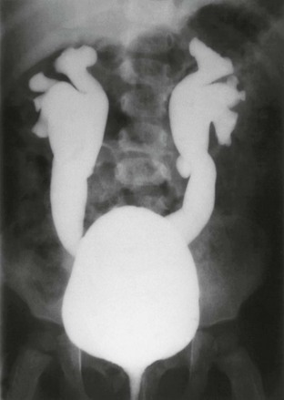
Figure 6: Voiding cystourethrogram (VCUG) image.
Images courtesy of PediatricEducation.org

Skull
The skull is very challenging for pediatric patients.3 Luckily, the frequency of skull examinations has decreased due to computed tomography (CT) and magnetic resonance imaging (MRI). Prepare the room in advance. A common pitfall is ineffective immobilization. A head clamp can be used for this purpose. Skull examinations are typically ordered to evaluate neurological problems or the extent of trauma or injury.

Extremities
Newborn – 2 years presents the most significant challenge for extremity examinations.2 Extremity examinations typically require the modified bunny-wrapping technique. Plexiglas can be used to immobilize the limb of interest. A Velcro band can be used for safety. Concentrate on immobilizing the affected limb. Figure 7 demonstrates AP and lateral images of the right knee with an acute, non-displaced oblique pathologic fracture through the distal right femur that occurs in an underlying radiolucent lesion that is well-marginated and most consistent in appearance with a non-ossifying fibroma.

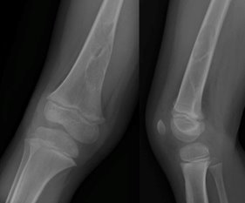
Figure 7: AP and lateral images of the right knee.
Images courtesy of PedicatricEducation.org

Preschoolers are best examined seated on their parent/caregiver/guardian’s lap to ensure the child will not fall off the table (Figure 8). If the parent/caregiver/guardian cannot assist, immobilize the child as described for younger children. School-aged children can be managed as adults.

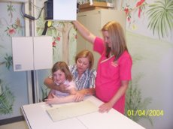
Figure 8: Child seated on their parent/caregiver/guardian’s lap for extremity examination.
Image provided by the author.

Evaluating Extremity Images
A considerable difference between adult and pediatric patients is the radiographic appearance of the limb.2 The presence of epiphyseal lines causes the difference. Contralateral images are commonly ordered for comparison purposes. Extremity imaging may demonstrate growth plate fractures and should demonstrate soft tissue and the bony trabecular pattern. Figure 9 images of an AP (left) and lateral (right) distal phalanx of the first toe demonstrates a subtle Salter-Harris Type II fracture. Figure 10 demonstrates a fracture of the distal ulna.

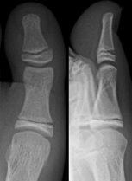
Figure 9: AP (left) and lateral (right) images of the first toe.
Images courtesy of PediatricEducation.org

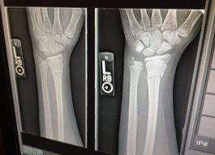
Figure 10: Ulnar fracture.
Images courtesy of PediatricEducation.org

Examinations Unique to the Pediatric Patient

Bone Age
Children can arrive at the imaging department with either underdeveloped skeletal development or advanced skeletal maturation.2 The appearance, size, and differentiation of various ossification centers determine the degree of skeletal maturation. The most common images to determine bone age are the AP of the left hand and wrist. Bone age protocols for children 1 to 2 years of life include an AP image of the left knee.

Aspirated and Ingested foreign bodies
Many pediatric patients examined in the emergency department present with a suspected aspirated or ingested foreign body.4 The first imaging examination should be images of the neck and chest. Foreign body aspiration is a common cause of respiratory distress in children months to 3 years old. The foreign body is often radiolucent, so it is easy to visualize. The first step is to differentiate between an esophageal ingestion and a tracheal aspiration. A lateral soft tissue neck image is needed if the foreign body is lodged in the trachea. Aspirated foreign bodies are more commonly lodged in the brachial tree and often on the right side than the left. Inspiration and expiration PA chest images are performed to determine if the object is lodged in the bronchus. A lateral chest and abdomen images may also be performed to determine the object's location. Figure 11A & B demonstrates an aspirated foreign object and Figure 11C & D demonstrates an ingested foreign object.

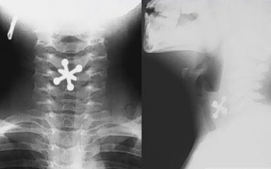

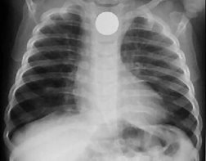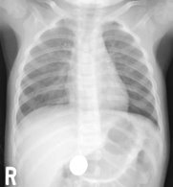
Figure 11. Demonstration of: an aspirated foreign object (A, B); and, an ingested foreign body (C, D).
Images courtesy of PediatricEducation.org

Scoliosis
Scoliosis is the presence of one or more lateral-rotary curvatures of the spine.2 Lateral means toward the side, and rotary refers to the vertebral column rotating around its axis. Scoliosis can be congenital or acquired after trauma. With modern equipment, the entire spine can be demonstrated in one image. Figure 12 displays PA or AP lateral projections of the entire spine on a single image receptor (IR).

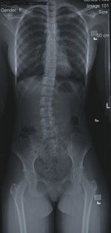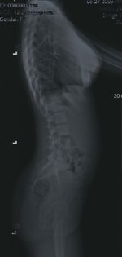
Figure 12: Scoliosis series.
Image provided by 

Suspected Child Abuse
The role of imaging in cases of child abuse is to identify the extent of physical injury when abuse is present and to elucidate all imaging findings that point to alternative diagnoses. Child abuse is any act of omission or commission that endangers or impairs a child's physical or emotional health and development. Unfortunately, the incidence of child abuse has increased in recent years. Child abuse includes physical abuse and neglect, emotional abuse, and sexual abuse. At some point, you will be called upon to take images of a child with suspected abuse. The RT has an ethical and perhaps legal obligation to report suspected child abuse to the radiologist or attending physician. In many states, healthcare professionals must report suspected cases of abuse or neglect. Any RT assigned to image a child's injuries and who notes bruising, burns, or possible fractures that seem out of proportion to the history of how the injury occurred, may need to consider abuse.

Classic indicators of physical abuse are numerous fractures at varied stages of healing.5 This demonstrates ongoing long-term abuse. Some radiologic indicators include posterior rib fractures, corner and "Bucket-handle" fractures of limbs, and a metaphyseal fracture. In these cases, skeletal surveys are recommended. It is best practice to center each body part accurately and separately.6 Avoiding a "babygram" (the entire body in one projection) image is best as this causes reduced diagnostic quality. Figure 13 A shows a “babygram.”

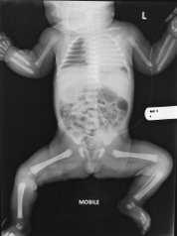
Figure 13. Babygram
Images courtesy of radiopaedia.org

The skeletal survey is mandatory in all cases of suspected child abuse in children younger than 2 years.5 The skeletal screening survey includes the recommended images:
- AP AND LATERAL SKULL
- AP AND LATERAL COMPLETE SPINE
- AP HUMERI
- AP FOREARMS
- AP PELVIS
- AP FEMORA
- AP TIBIAE AND FIBULAE
- AP FEET
- AP AND LATERAL RIBS

Long bone fractures are the most common fracture in abused children, as seen in Figure 14, an AP radiograph of the left femur demonstrates a complete fracture of the femoral diaphysis with minimal angulation and overriding of the fracture fragments.⁶ Some fractures are typical for an age group. For example, hip fractures are common in older adults, not children. Also, it is not common for an infant to have a skull fracture from a fall from a changing table.

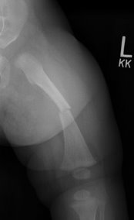
Figure 14: An AP radiograph of the left femur demonstrates a complete fracture of the femoral diaphysis with minimal angulation and overriding of the fracture fragments.
Image courtesy of PediatricEducation.org

Conclusion
Pediatric imaging requires experience and practice to gain confidence and competence. The pediatric patient ranges in age from newborn to 18 years. The RT must relate to all patients appropriately and specifically, regardless of age. Children are impressionable and dependent on their caregivers, but they are also often the best teachers radiologic technologists can have. Radiologic technologists should watch and listen to these small patients, observe their body language and facial expressions, and note their questions and reactions for cues regarding ways to respond to them. Ultimately, the rewards- a child's smile and trust- are given more frequently than expected.

References

Thukral BB. Problems and preferences in pediatric imaging. Indian J Radiol Imaging. 2015;25(4):359- 364. doi:10.4103/0971-3026.169466
Rollins JH, Long BW, Curtis T. Merrill's Atlas of Radiographic Positioning and Procedures. 15th ed. Volume 3. St. Louis, MO: Elsevier; 2023.
Merrow AC, Aquino MR, Linscott LL, Koch BL. Diagnostic Imaging: Pediatrics, 4th ed. St. Louis, MO: Elsevier; 2023.
Lucignani G. Customized imaging for children and obese people: key issues and strategies. European Journal of Nuclear Medicine and Molecular Imaging. 2006; 33(11), 1364–1368.
American Academy of Pediatrics. Diagnostic Imaging of Child Abuse. Pediatrics. 2009; 123(5). 1430-1435.
Lampignano JP, Kendrick L. Bontragers' Textbook of Radiographic Positioning and Related Anatomy. 10th ed. St. Louis, MO: Elsevier; 2021.

